UNITED STATES
SECURITIES AND EXCHANGE COMMISSION
Washington, D.C. 20549

FORM 8-K
CURRENT REPORT
PURSUANT TO SECTION 13 OR 15(d) OF
THE SECURITIES EXCHANGE ACT OF 1934
Date of Report (Date of earliest event reported): August 3, 2021

HELMERICH & PAYNE, INC.
(Exact name of registrant as specified in its charter)

DE |  |  |  |  |  | 1-4221 |  |  |  |  |  | 73-0679879
(State or other jurisdiction of  Incorporation) |  |  |  |  |  | (Commission File  Number) |  |  |  |  |  | (I.R.S. Employer  Identification No.)

1437 South Boulder Avenue, Suite 1400
Tulsa, OK 74119
(Address of principal executive offices and zip code)
(918) 742-5531
(Registrant’s telephone number, including area code)
N/A
(Former name or former address, if changed since last report)
Securities registered pursuant to Section 12(b) of the Act:

Title of each class |  |  | Trading symbol(s) |  |  | Name of each exchange on which registered
Common Stock ($0.10 par value) |  |  | HP |  |  | NYSE

Check the appropriate box below if the Form 8-K filing is intended to simultaneously satisfy the filing obligation of the registrant under any of the following provisions (see General Instruction A.2.):

☐ Written communications pursuant to Rule 425 under the Securities Act (17 CFR 230.425)
☐ Soliciting material pursuant to Rule 14a-12 under the Exchange Act (17 CFR 240.14a-12)
☐ Pre-commencement communications pursuant to Rule 14d-2(b) under the Exchange Act (17 CFR 240.14d-2(b))
☐ Pre-commencement communications pursuant to Rule 13e-4(c) under the Exchange Act (17 CFR 240.13e-4(c))

Indicate by check mark whether the registrant is an emerging growth company as defined in Rule 405 of the Securities Act of 1933 (§230.405 of this chapter) or Rule 12b-2 of the Securities Exchange Act of 1934 (§240.12b-2 of this chapter).

Emerging growth company ☐

If an emerging growth company, indicate by check mark if the registrant has elected not to use the extended transition period for complying with any new or revised financial accounting standards provided pursuant to Section 13(a) of the Exchange Act. ☐

ITEM 5.02 DEPARTURE OF DIRECTORS OR CERTAIN OFFICERS; ELECTION OF DIRECTORS; APPOINTMENT OF CERTAIN OFFICERS; COMPENSATORY ARRANGEMENTS OF CERTAIN OFFICERS.

Effective August 3, 2021, the Board of Directors (the "Board") of Helmerich & Payne, Inc. (the “Company”), upon the recommendation of the Nominating and Corporate Governance Committee of the Board, approved the expansion of the Board from 11 members to 12, and appointed Belgacem Chariag as a new director of the Company. Mr. Chariag has also been appointed to serve on the Human Resources Committee and Nominating and Corporate Governance Committee of the Board.

As a non-employee director of the Company, Mr. Chariag will receive the same standard compensation provided to all non-employee members of the Board. As such, in connection with his appointment, Mr. Chariag received (a) a pro-rated quarterly cash retainer fee of $7,880 and (b) an initial prorated award (under the Helmerich & Payne, Inc. 2020 Omnibus Incentive Plan) of 3,645 restricted shares which will vest one year from the grant date.

ITEM 7.01 REGULATION FD DISCLOSURE.

On August 3, 2021, the Company issued a press release announcing the expansion of the Board and the appointment of Mr. Chariag as a new director. The press release is attached as Exhibit 99.1 to this Current Report on Form 8-K.

This information is being furnished pursuant to Item 7.01 of this Current Report on Form 8-K and shall not be deemed to be “filed” for the purposes of Section 18 of the Securities Exchange Act of 1934, as amended (the “Exchange Act”), or otherwise subject to the liabilities of that Section, nor shall it be deemed incorporated by reference in any filing under the Securities Act of 1933, as amended, or the Exchange Act, except as shall be expressly set forth by specific reference in such a filing.

ITEM 9.01 FINANCIAL STATEMENTS AND EXHIBITS.

(d) Exhibits

EXHIBIT NUMBER |  |  | DESCRIPTION
99.1 |  |  | Press release dated August 3, 2021, issued by the Company.
104 |  |  | Cover Page Interactive Data File - the cover page XBRL tags are embedded within the Inline XBRL document.

SIGNATURE

Pursuant to the requirements of the Securities Exchange Act of 1934, as amended, the registrant has duly caused this report to be signed on its behalf by the undersigned hereunto duly authorized.

 |  |  | HELMERICH & PAYNE, INC.
 |  |  | By: |  |  | /s/ William H. Gault
 |  |  | Name: |  |  | William H. Gault
 |  |  | Title: |  |  | Corporate Secretary  Date: August 5, 2021

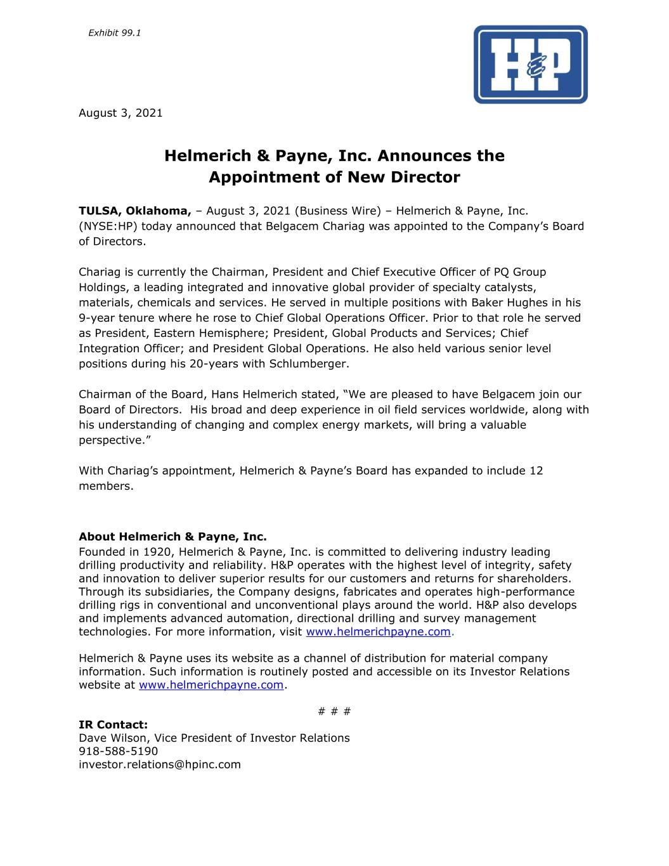
August 3, 2021 Helmerich & Payne, Inc. Announces the Appointment of New Director TULSA, Oklahoma, – August 3, 2021 (Business Wire) – Helmerich & Payne, Inc. (NYSE:HP) today announced that Belgacem Chariag was appointed to the Company’s Board of Directors. Chariag is currently the Chairman, President and Chief Executive Officer of PQ Group Holdings, a leading integrated and innovative global provider of specialty catalysts, materials, chemicals and services. He served in multiple positions with Baker Hughes in his 9-year tenure where he rose to Chief Global Operations Officer. Prior to that role he served as President, Eastern Hemisphere; President, Global Products and Services; Chief Integration Officer; and President Global Operations. He also held various senior level positions during his 20-years with Schlumberger. Chairman of the Board, Hans Helmerich stated, “We are pleased to have Belgacem join our Board of Directors. His broad and deep experience in oil field services worldwide, along with his understanding of changing and complex energy markets, will bring a valuable perspective.” With Chariag’s appointment, Helmerich & Payne’s Board has expanded to include 12 members. About Helmerich & Payne, Inc. Founded in 1920, Helmerich & Payne, Inc. is committed to delivering industry leading drilling productivity and reliability. H&P operates with the highest level of integrity, safety and innovation to deliver superior results for our customers and returns for shareholders. Through its subsidiaries, the Company designs, fabricates and operates high-performance drilling rigs in conventional and unconventional plays around the world. H&P also develops and implements advanced automation, directional drilling and survey management technologies. For more information, visit www.helmerichpayne.com. Helmerich & Payne uses its website as a channel of distribution for material company information. Such information is routinely posted and accessible on its Investor Relations website at www.helmerichpayne.com. # # # IR Contact: Dave Wilson, Vice President of Investor Relations 918-588-5190 investor.relations@hpinc.com Exhibit 99.1

